Compare Files Tool

Overview

Compare Files Tool provides a simple solution to compare two files. It supports excel files and all other files with different extensions (e.g. .csv, .txt, .xml etc.) which can be opened with Microsoft excel tool.

# Requirements

* Java 1.6.0 or higher
* Microsoft Excel

**Compare Files Tool at a Glance**

1. Extract Compare files folder and keep the extracted folder at your desired location.
2. Run Compare files.exe.

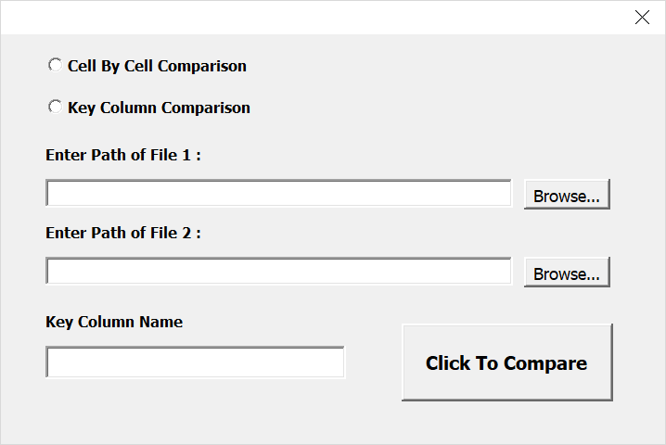

1. Choose the comparison Type :
   1. Cell by Cell Comparison – Compares two files cell by cell
   2. Key Column Comparison – Compares one file to another with reference to a key column.
2. Enter Path of Files by either pasting in field or through browsing file explorer.
3. Provide the name of Key column if “Key Column Comparison” type is selected.
4. Press “Click to Compare” button. A progress bar appears to show the % of task completion.

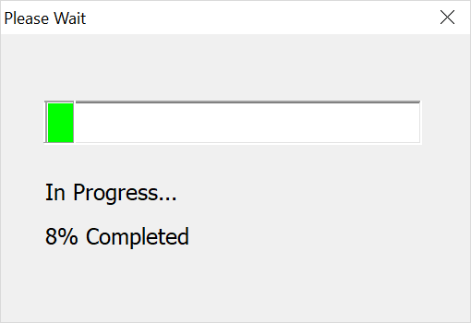

1. Once the comparison is completed a success pop up appears.

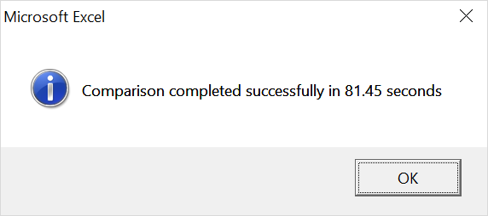

1. A excel file gets generated under “Result Files” folder in “Compare Files” folder.

* This file contains two sheets. Sheet 1 contains the data from File 1 and Sheet 2 contains the data from File 2.
* Cell by Cell Comparison – Color of all non matching cells changes to red.
* Key column comparison – Color of all non matching cells changes to red. Also if any Key column value of one file is not present in the other file, it’s color changes to orange.